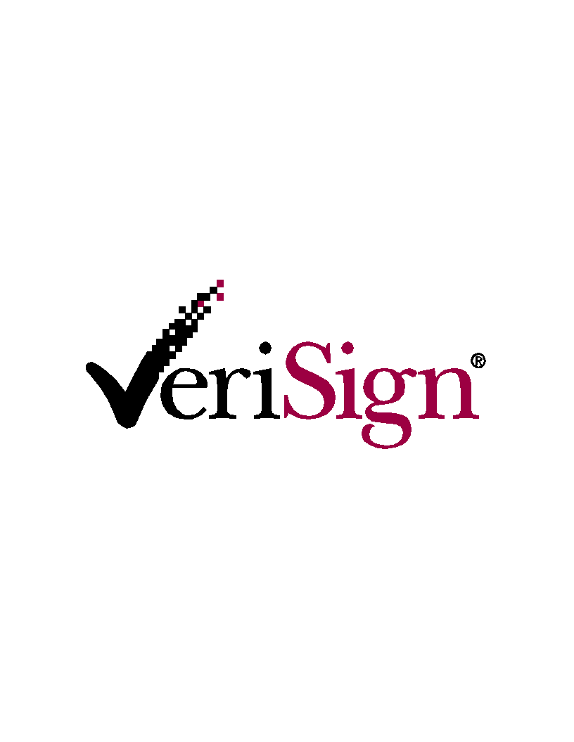

Invitation to Whois Consultation

VeriSign invites you to participate in a meeting
to discuss development of a Universal Whois Service
that will allow public access and effective use of Whois
across Registries and TLDs
(As specified in Appendix W of its Registry Agreement)

Date: Thursday, November 15, 2001
Time: Immediately following the ICANN Board Meeting
(Likely 6 – 7:30pm)
Place: Catalina Room, Marina Beach Marriott, Marina del Rey, CA

If you have specific thoughts about the type of R&D needed to meet the requirements for a Universal Whois Service and would like to present them, please indicate that when you RSVP and come prepared to make a one-to-five minute presentation.
Thank you for your interest and participation.

Please RSVP to Sarah Daisy Splitt ssplitt@verisign.com

* * * * *
Please Note: This is the second of three consultations that VeriSign is holding to solicit participation in this research and development effort specified in its Registry Agreement. The first meeting was held in Washington, DC on August 15 and focused on input from business, intellectual property and law enforcement interests. The November 15 consultation is designed to reach out to the international community. As a result of increased concern by some about travel and security, and our belief that many of the people who would have wanted to attend a consultation overseas will already be in Marina del Rey, we have decided against holding a separate meeting in Europe, Asia or elsewhere. We are instead scheduling the international consultation to begin immediately after the close of the November ICANN meeting in Marina del Rey.

The third consultation will focus on input from civil liberties groups and be hosted by the Center for Democracy and Technology in Washington, DC on November 19. More details will be forthcoming shortly. All of these consultations are open to anyone who would like to participate.

In addition to these formal consultations, VeriSign has held, or plans to hold, informal consultations on the margins of key international technical meetings for those attendees, including:
- RIPE - October 3-4, 2001 (DNR Working Group and Database Working Group), Prague
- NANOG - October 23, 2001, Oakland
- ARIN - October 29-31, Miami
- RIPE - January 14-19, 2002, Amsterdam (tentative)
- APRICOT - March 3-7, 2002, Bangkok (tentative)

We have also set up a website to enable anyone, anywhere, to provide input. It can be accessed at http://uwho.verisignlabs.com.

